**Enes Garip-150116034**

**CSE225 DATA STRUCTURES PROJECT #2** **REPORT**

a) and b)

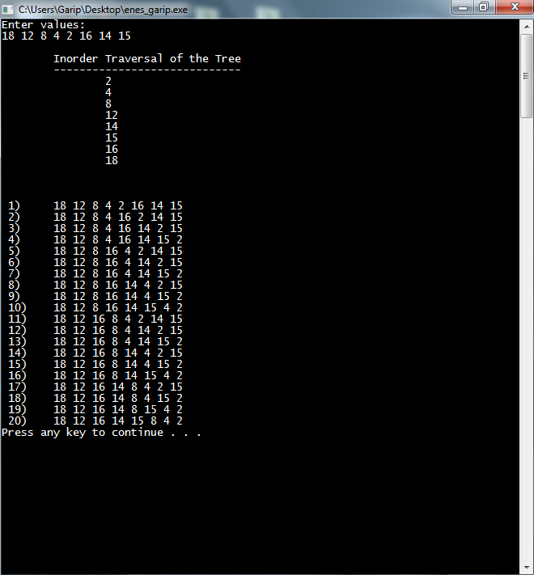

c)

In my algorithm, I suppose that all permutations of the binary search tree includes the permutations of same topology. So, firstly, a permutation function finding all the permutations of the tree but when the input numbers increase, printing all permutations is bothering. I create another tree for temporary for all permutations. When new permutation comes, the tree recreate itself with new inputs. Then, each temporary tree comparing itself to the original one and if both are the same, the tree of that permutation has same topology with the original tree and prints that permutation to the screen.